**A Project Report on**

**Classification of internet Advertisement using orange tool**

Project Report submitted in partial Fulfilment of the requirement for the award of

**Data Mining and Application (CA3106)**

**Submitted By:-**

**GopalKrushna Padhi-2061020073**



**DEPARTMENT OF MCA (2020-22)**

**ITER, SOA UNIVERSITY**

**JagamohanNagar, Jagamara, Bhubaneswar, Odisha –751030**

**ABSTRACT:-**

The investigation of web ad is vital now daily in human existence. Commercial and their connected regions are economy concern business has become an outstanding field in the wide spread region. Publicizing area are producing part of data and information which help to comprehend and should be examination, propositions information are should change over into significant information. To utilize these clients' data, settle on future choice and accomplish powerful choices, these choices help to comprehend client's need and utilization of the labor and products. Utilize client's information and carry out information mining strategies to get familiar with clients' examples and discover answer for conquer the market prerequisite. There is a shortfall of appropriate looking at instrument according to outfit convincing business sector overview results along with the concealed information, so and such a system is made using data burrowing computations for describing the data and to perceive the clients necessity. In promoting issues information mining give arrangement. For web promoting there are 5 calculations which help to discover examples and arrangement these are Random Forest, Tree, KNN, Constant and Naïve Bayes calculation which help to finding client issues. In this examination paper I am utilizing information mining apparatus Orange and breaks down boundaries and discover client's prerequisite through web promotion as for the information mining draws near.

**Keywords:**

Orange, introduction and about the dataset, data mining, Orange data mining tools, About Internet advertisement.

**DATA MINING TECHNIQUES:**

There many kinds of procedures yet mainstream methods are:

1. Classification learning

2. Numeric prediction

3. Association rule mining

4. Clustering

**Classification learning**: In Statistics, ML Machine Learning is a regulated learning method wherein they learn program of PC where information is input given to it after that they use to become familiar with the order ground-breaking perceptions.

Numeric expectation: is connected to getting the accompanying an impetus in the stream and here one isn't attempting to estimate the class rather the value or capacities.

**Affiliation rule mining:** ML AI is Rule Based realizing which is finding relations between factors in enormous DB and it is expected to recognize extremely impressive guideline happened in DB.

**Clustering:** might be a division of information into gatherings of associated objects. Portraying the data a few bunches principally loses certain restrict subtleties, yet achieves improvement. Information mining strategies are relying upon which information are generally reasonable for and which methods are use and settling issues in information mining on these sorts. Information is to stand and utilize the determination of the decision of data mining strategy which is by and large sensible for the data used.

**ABOUT ORANGE TOOL:-**

Orange is an open-source information representation, AI and information mining tool compartment. It includes a visual programming front-end for explorative quick subjective information investigation and intelligent information representation. Orange parts are called gadgets and they range from basic information representation, subset choice, and pre-handling, to observational assessment of learning calculations and prescient displaying. Visual writing computer programs is carried out through an interface where work processes are made by connecting predefined or client planned gadgets, while progressed clients can utilize Orange as a Python library for information control and gadget change. Various assessments is possible through its visual programming interface that is move related with contraptions and various visual mechanical assemblies will overall be maintained, for instance, reference charts, trees, disperse plots graph, lair projects and warmth maps.

**INTRODUCTION OF INTERNET ADVERTISEMENT:-**

In this universe of innovation nearly everything happens online let it be instruction or shopping or banking, in such a time of innovation our method of notice has additionally changed. Prior notice used to come on TV which were observed just a restricted gathering of individuals, prior TV likewise couldn't be managed by everybody so commercial was exceptionally restricted however presently we have everything on our fingertips with the assistance of web, web is utilized by everybody and all over . Be that as it may, it is so hard to track down client's issues in introductory stage and the greater part of the makers or merchants can't as expected discover circumstance since necessity are of many kinds. Thus, makers and merchants took on numerous technique and logical advances to recognize. These innovations lead to assist with dissecting not exclusively client's advantage yet in addition different fields with the assistance of web publicizing.

**Exploration QUESTION:-**

For my situation study depends on Classification of Internet Advertisement with utilizing Orange apparatus and distinguish examples and discover which characterization calculations are ideal and have more exact then my other examination questions are:

• Which Classification calculations work best?

• Using Orange instrument which arrangement calculation is precise in web notice?

**Introduction of Data Mining:-**

"Information mining" that mines the information. it is characterized as discovering covered up insights(information) from the data set, extricate designs from the information . There are various calculations for different assignments. The capacity of those calculations is to suit the model. These calculations distinguish the attributes of information. There are 2 kinds of models.

1) Predictive model

2) Descriptive model

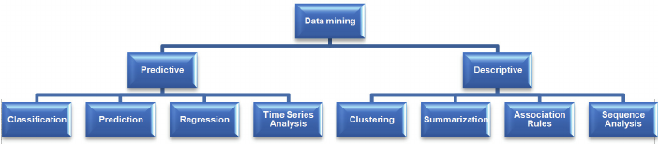**About The Dataset:**

This dataset addresses a bunch of potential commercials on Internet pages. The components encode the math of the picture (if accessible) just as expressions happening in the URL, the picture's URL and alt text, the anchor text, and words happening close to the anchor text. The undertaking is to foresee whether a picture is a promotion ("advertisement") or not ("non-advertisement").

We have,

3279 number of instance,

1558 number of attributes, where we have 3 continuous and other binary n the attributes characterises are categorical integer and real type

At least one of the three persistent elements are absent in 28% of the occurrences; missing qualities ought to be deciphered as "obscure" with every one of these we are having likewise some more things to examine the task dataset. We have,

457 components from url terms

495 components from origurl terms

472 components from ancurl terms

111 elements from alt terms

19 elements from subtitle terms and the Class Distribution is number of examples per class 2821 non-promotions, 458 advertisements.

**Dataset Link-** https://www.kaggle.com/uciml/internet-advertisements-data-set

**Test and Score:**

The widget tests learning algorithms. Different sampling schemes are available, including using separate test data. The widget does two things. First, it shows a table with different classifier performance measures, such as [classification accuracy](https://en.wikipedia.org/wiki/Accuracy_and_precision) and [area under the curve](https://en.wikipedia.org/wiki/Receiver_operating_characteristic#Area_under_the_curve). Second, it outputs evaluation results, which can be used by other widgets for analysing the performance of classifiers, such as [ROC Analysis](https://orange3.readthedocs.io/projects/orange-visual-programming/en/latest/widgets/evaluate/rocanalysis.html) or [Confusion Matrix](https://orange3.readthedocs.io/projects/orange-visual-programming/en/latest/widgets/evaluate/confusionmatrix.html).

The widget supports various sampling methods which are as follows:

1. **Cross validation:**

We can split the data between 5-10.

In this we have taken, Number of folds: 10

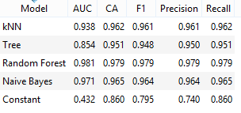

1. **Random sampling*:***

We have taken,

Repeat train/test: 5

Training set size: 66%

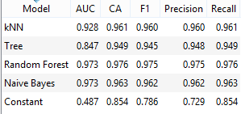

**Random Forest:**

An irregular timberland is an AI procedure that is utilized to tackle relapse and order issues. It uses troupe realizing, which is a strategy that joins numerous classifiers to give answers for complex issues Random Forest forms a bunch of choice trees. Each tree is created from a bootstrap test from the preparation information. When creating singular trees, a subjective subset of traits is drawn (thus the expression "Arbitrary"), from which the best characteristic for the split is chosen. The last model depends on the greater part vote from separately created trees in the woods.

The basic properties of Random Forest are:

* No of trees
* No of trees considered at each split
* Balance class distribution

**Development control:**

* Limit profundity of individual tree
* Do not split subsets more modest

In our document we have taken,

Number of trees: 10

Do not split subsets smaller than: 5

**Tree:**

Tree is a straightforward calculation that divides the information into hubs by class immaculateness. It is a forerunner to Random Forest. Tree in Orange is planned in-house and can deal with both discrete and ceaseless datasets. It can likewise be utilized for both grouping and relapse errands.

**The parameters of tree are:**

•Induce double tree

•Min. number of occurrences in leaves

•Do not split subsets less than

•Limit the maximal tree profundity

**Classification:**

Stop when greater part comes to [%]: quit dividing the hubs after a predefined greater part limit is reached.

In our dataset we have utilized the accompanying boundaries:

Incite double tree= Enabled

Least number of cases in leaves=2

Try not to divide subsets more modest than=5

Cut-off the maximal dept to=100

Stop when greater part reaches=95%

# kNN:-

The kNN gadget utilizes the kNN calculation that looks for k nearest preparing models in include space and uses their normal as expectation.

The Weights you can utilize are:

▪ uniform: all focuses in every area are weighted similarly.

▪ Distance: closer neighbours of a question point have a more prominent impact than the neighbors further away

# Confusion Matrix:-

The Confusion Matrix gives the number/extent of examples between the anticipated and real class. The determination of the components in the grid takes care of the comparing occasions into the yield signal.

The gadget generally gets the assessment results from Test and Score; an illustration of the blueprint is displayed underneath.

***kNN:***

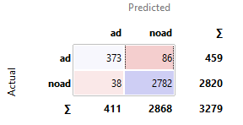

***Tree:***

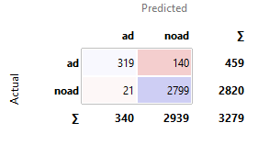

***Naive Bayes:***

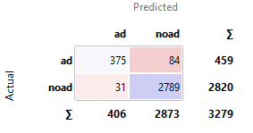

***Random Forest:***

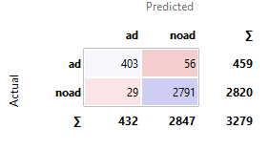

***Constant:***

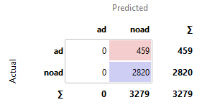

The depiction shows the disarray grid for Tree, Naive Bayesian, kNN, Random woodland, and Constant models prepared and tried on the web advertisement information.

**Correlation:**

It processes Pearson or Spearman relationship scores for all sets of components in a dataset. These techniques can just distinguish monotonic relationship. Connections can be registered distinctly for numeric (constant) highlights. Decidedly related component sets will be at the first spot on the list and adversely associated will be at the base.

***Correlation measure:***

* **Pairwise Pearson connection.**
* **Pairwise Spearman connection.**

In our dataset we have used Pearson correlation and all combination includes aratio, height and width.

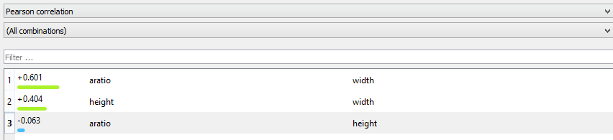

**Pivot table:-**

Turn Table sums up the information of a more broad table into a table of measurements. The insights can incorporate aggregates, midpoints, tallies, and so forth The gadget likewise permits choosing a subset from the table and gathering by column esteems, which must be a discrete variable. Information with just numeric factors can't be shown in the table. In turn table these are the boundaries:

**• Discrete or numeric variable utilized for line esteems.**

**• Discrete variable utilized for section esteems**

**• Aggregated qualities will show up as cells in the table.**

**Aggregation methods are:**

Count, Count defined, Sum, Mean, Median, Mode, Min, Var, Majority(most frequent value of the subset)

In this dataset we have used,

Rows =class

Columns =class

Values =height

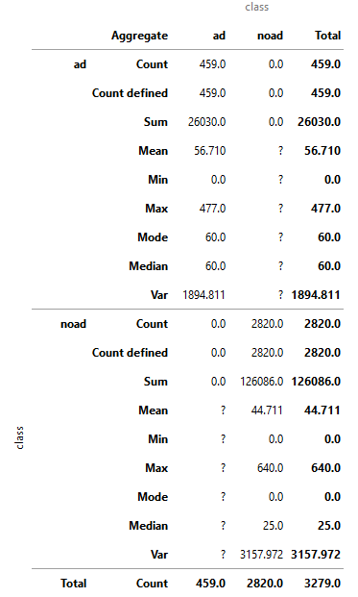

In aggregation we have used all the methods for both ‘ad’ and ‘non-ad’ and we get output as:

|  |  |  |  |
| --- | --- | --- | --- |
| **Count defined** | 459.0 | 2820.0 | 3279.0 |
| **Sum** | 26030.0 | 126086.0 | 152116.0 |
| **Mean** | 56.710 | 44.711 | 46.391 |
| **Min** | 0.0 | 0.0 | 0.0 |
| **Max** | 477.0 | 640.0 | 640.0 |
| **Mode** | 60.0 | 0.0 | 0.0 |
| **Median** | 60.0 | 25.0 | 31.0 |
| **Var** | 1894.811 | 3157.972 | 2998.485 |

# Sieve Diagram

A Sieve Diagram is a graphical strategy for envisioning frequencies in a two-manner possibility table and contrasting them with anticipated frequencies under supposition of autonomy. It was proposed by Riedwyl and Schüpbach in a specialized report in 1983 and later called a parquet outline (Riedwyl and Schüpbach 1994). In this presentation, the space of every square shape is relative to the normal recurrence, while the noticed recurrence is displayed by the quantity of squares in every square shape. The contrast among noticed and anticipated recurrence (relative to the standard Pearson leftover) shows up as the thickness of concealing, utilizing shading to demonstrate whether the deviation from

Autonomy is positive (blue) or negative (red).

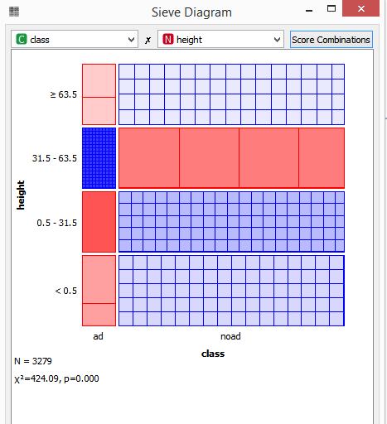

We take ‘class’ in X-axis ‘height’ in Y-axis to display the Sieve Diagram

*Result:*

N= 3279

X2= 424.09

P= 0.000

|  |  |
| --- | --- |
| ***Class and Height*** | ***Combination of Values*** |
| **Class = ad:** 459/3279 (14%)  **Height >= 63.5:** 793/3279 (24%) | **Excepted** 111.01 (3%)  **Observed** 84 (3%) |
| **Class = ad:** 459/3279 (14%)  **Height in 31.5 – 63.5:** 790/3279 (24%) | **Excepted** 110.59 (3%)  **Observed** 281 (9%) |
| **Class = ad:** 459/3279 (14%)  **Height in 0.5 – 31.5:** 793/3279 (24%) | **Excepted** 111.01 (3%)  **Observed** 21 (1%) |
| **Class = ad:** 459/3279 (14%)  **Height < 0.5:** 903/3279 (28%) | **Excepted** 126.04 (4%)  **Observed** 73 (2%) |
| **Class = non-ad:** 2820/3279 (86%)  **Height >= 63.5:** 793/3279 (24%) | **Excepted** 681.99 (21%)  **Observed** 709 (22%) |
| **Class = non-ad:** 2820/3279 (86%)  **Height in 31.5 – 63.5:** 790/3279 (24%) | **Excepted** 679.41 (21%)  **Observed** 509 (16%) |
| **Class = non-ad:** 2820/3279 (86%)  **Height in 0.5 – 31.5:** 793/3279 (24%) | **Excepted** 681.99 (21%)  **Observed** 772 (24%) |
| **Class = non-ad:** 2820/3279 (86%)  **Height < 0.5:** 903/3279 (28%) | **Excepted** 776.60 (24%)  **Observed** 830 (25%) |

# Box Plot:-

# The **Box Plot** widget shows the distributions of attribute values. It is a good practice to check any new data with this widget to quickly discover any anomalies, such as duplicated values, outliers, and alike. Bars can be selected - for example, values for categorical data or the quintile range for numeric data.

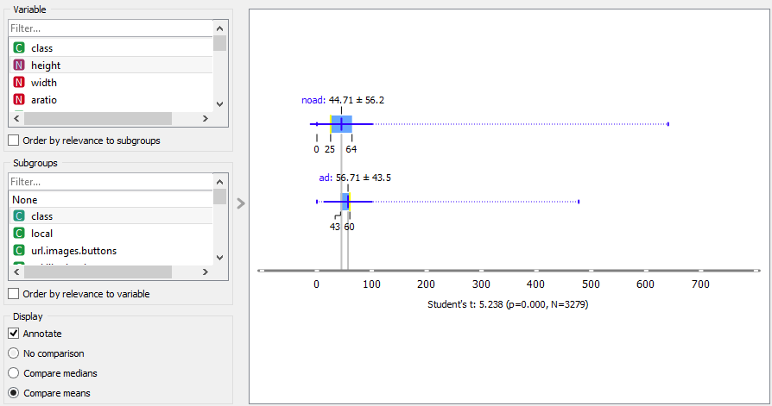

**Data Flow Diagram:-**

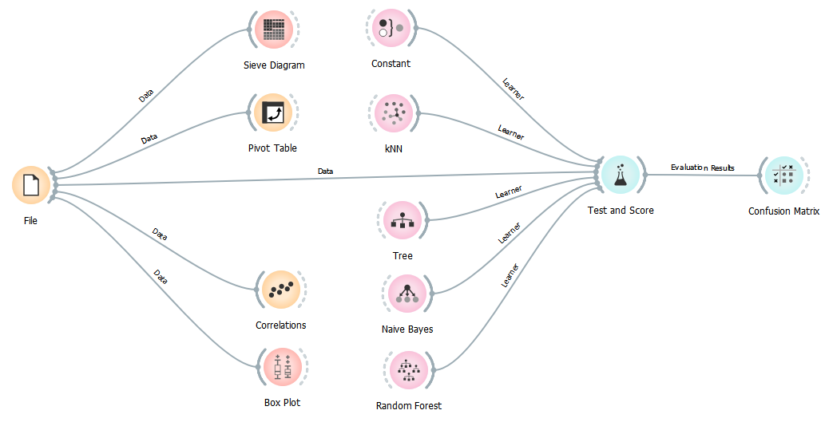

**Conclusion and future scope:-**

In this segment restates the finish of study information mining alongside web publicizing have been a significant stage for some business in 21th progressively enormous data sets and market division. In enormous nation like India which has a different culture, language and numerous other social factor, which are to be broke down to have better substance. These examinations with an alternate mix of factors might give great knowledge into the need and assumption for the present-day customers just as future purchasers. Another scale to gauge by and large assumption, perspectives and fulfilment can be contrived and experimentally tried.

**REFERENCES:-**

1. Gal-Moscovici A, Sprague SM. Bone health in chronic kidney disease-mineral and bone disease. Adv.Chronic.Kidney Dis. 2007;14:27–36. [PubMed] [Google Scholar]
2. Cabena, Peter; Hadjnian, Pablo; Stadler, Rolf; Verhees, Jaap; Zanasi, Alessandro (1997); *Discovering Data Mining: From Concept to Implementation*, [Prentice Hall](https://en.wikipedia.org/wiki/Prentice_Hall), [ISBN](https://en.wikipedia.org/wiki/ISBN_(identifier)) [0-13-743980-6](https://en.wikipedia.org/wiki/Special:BookSources/0-13-743980-6)
3. M.S. Chen, J. Han, [P.S. Yu](https://en.wikipedia.org/wiki/Philip_S._Yu) (1996) "[Data mining: an overview from a database perspective](http://cs.nju.edu.cn/zhouzh/zhouzh.files/course/dm/reading/reading01/chen_tkde96.pdf)". *Knowledge and data Engineering, IEEE Transactions* on 8 (6), 866–883
4. Fraser SD, Roderick PJ, Aitken G, et al., albuminuria and socioeconomic status in the Health Surveys for England 2009 and 2010. J Public Health (Oxf) 2014;36(4):577–586. [PubMed] [Google Scholar]
5. BixiaGao, ... ShougangZhuang, in Data mining orange (Second Edition), 2020
6. KDOQI Clinical Practice Guidelines and Clinical Practice Recommendations for Anemia in data Am.J.Kidney Dis. 2006;47:S11–S145. [PubMed] [Google Scholar]
7. McClellan W, Aronoff SL, Bolton WK, et al. The prevalence of anemia in patients with chronic kidney disease. Curr.Med.Res.Opin. 2004;20:1501–1510. [PubMed] [Google Scholar]
8. Feldman, Ronen; Sanger, James (2007); *The Text Mining Handbook*, [Cambridge University Press](https://en.wikipedia.org/wiki/Cambridge_University_Press), [ISBN](https://en.wikipedia.org/wiki/ISBN_(identifier)) [978-0-521-83657-9](https://en.wikipedia.org/wiki/Special:BookSources/978-0-521-83657-9)

**External Links:-**

<https://www.javatpoint.com/data-mining-techniques>

[https://en.wikipedia.org/wiki/Orange -(software)](https://en.wikipedia.org/wiki/Orange%20%20-(software))

**For Dataset-**https://www.kaggle.com/uciml/internet-advertisements-data-set